7/15/2024

Vaishnavi Samal

group - 2

Infosys Springboard Internship

Hate Speech Detection in Tweeter Platform

1. **Business Problem**

In today's digital age, hate speech on online platforms is a growing concern that impacts individuals and communities globally. Social media platform like Twitter host billions of users who generate a vast amount of content daily

* Challenges:

1. Psychological Harm: Hate speech can cause significant emotional and psychological distress to targeted individuals and groups.
2. Social Unrest: It has the potential to incite violence, perpetuate discrimination, and destabilize communities.
3. Legal Risks: Platforms face increasing legal scrutiny and potential penalties for failing to manage hate speech effectively.
4. Brand Reputation: Inadequate management of hate speech can severely damage the platform’s reputation and credibility.

**2.Proposed Solution**

To address the problem of hate speech on online platforms, we propose developing a machine learning model that can automatically detect and categorize user-generated content into hate speech/offensive language and neutral content. The solution involves the following steps:

1. Data Collection: Gather a diverse and comprehensive dataset of user-generated content from Twitter platforms.
2. Data Labeling: Ensure accurate labeling of content into the categories of hate speech/offensive language, or neutral.
3. Model Training: Use the labeled dataset to train a robust machine learning model.
4. Evaluation: Test and validate the model to ensure high accuracy and reliability in detecting hate speech.

Deployment: Integrate the model into online platforms to assist in real-time content moderation.

**3.Dataset Description**

After gone through various datasets, we selected Davidson dataset that best met our criteria for comprehensiveness, diversity, and quality. The key reasons for our choice include:

**1.Comprehensive and Representative:**

* + **Extensive Coverage:** Over 24,000 entries, covering a wide range of hate speech scenarios and user-generated content from various platforms.

**2.Quality and Accuracy:**

* + **Rigorous Annotation:** Multiple annotators from diverse backgrounds reviewed and labeled each entry, ensuring high accuracy and consistency.

**3.Relevance and Impact:**

* + **Operational Efficiency:** Enhances user experience by reducing exposure to hate speech, potentially increasing user engagement and retention, thus boosting platform revenue and reducing the risk of legal penalties.

**4. Labeled Categories:**

* + Each tweet is labeled as hate speech, offensive language, or neutral content.

**5. Dataset Structure:**

* + **count:** Number of occurrences/interactions of the tweet.
  + **hate_speech:** Indicates the presence of hate speech in the tweet.
  + **offensive_language:** Indicates the presence of offensive language in the tweet.
  + **neither:** Indicates the tweet does not contain hate speech or offensive language.
  + **class:** Categorization of the tweet (2 = neither, 1 = offensive language, 0 = hate speech).
  + **tweet:** The actual text content of the tweet.
* Example: 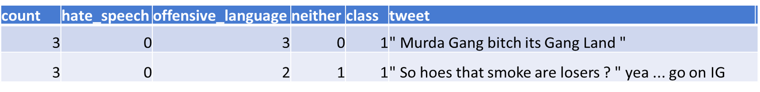

**4.Data Distribution**

* **Data Distribution in the Original Dataset:**

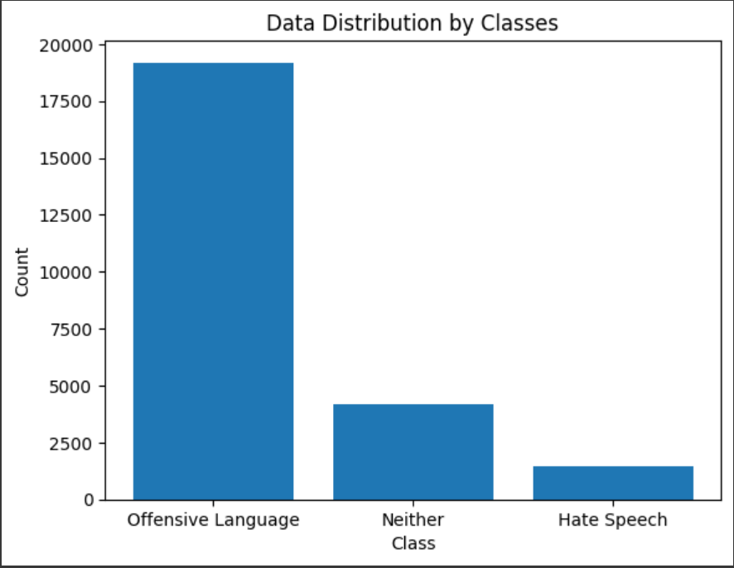

* **Label wise distribution of Train dataset:**

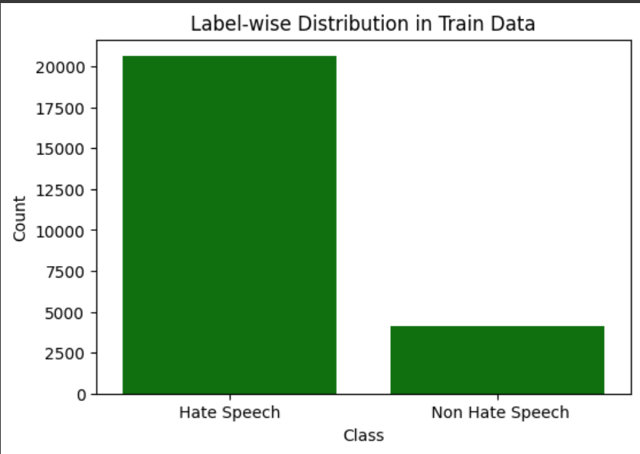

* **Train, Test and Validation Data Size:**

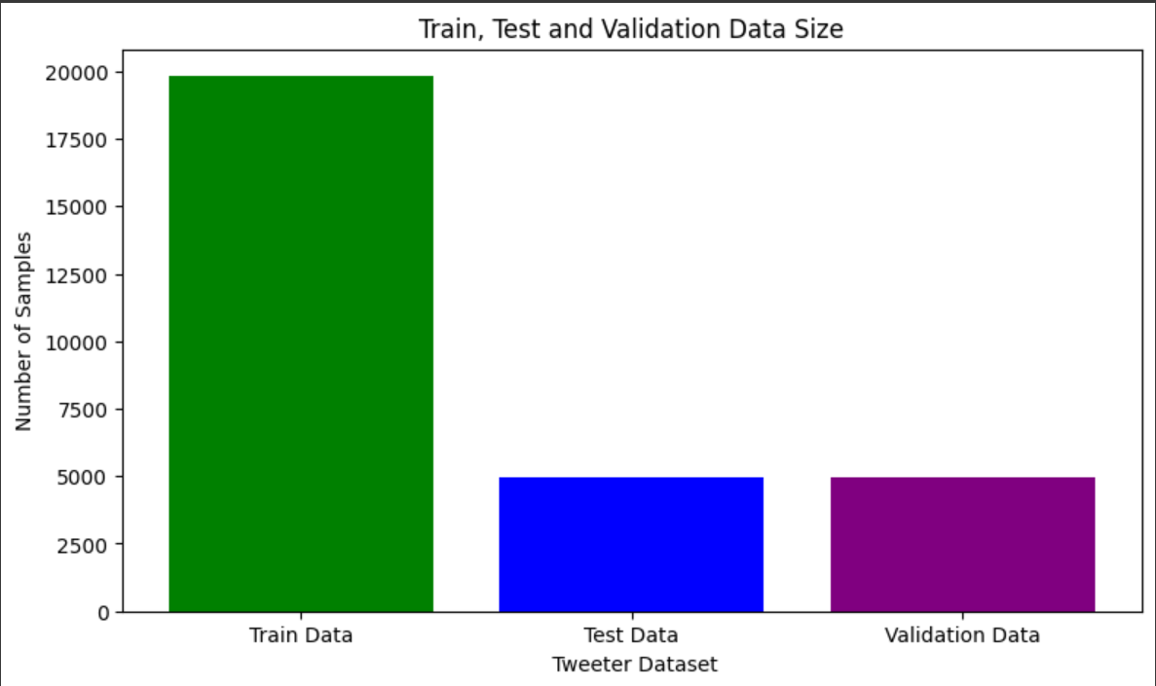

1. **Data Preprocessing**

Data preprocessing is a process of preparing the raw data and making it suitable for a machine learning model. It is the first and crucial step while creating a machine learning model. Steps included for Data Preprocessing:

1. **Recategorization:** Hate speech and offensive language as 0, non-hate speech as 1
2. **Handling missing values:** Replaced with empty strings
3. **Handling duplicates:** Removed duplicates
4. **Handling abbreviations:** Replaced with full forms
5. **HTML entity decoding:** Decoded HTML entities
6. **Contraction expansion:** Expanded contractions
7. **Normalization:** Applied normalization to the data
8. **Tokenization and embedding techniques**

* **Tokenization**: **Word Tokenization**

Word tokenization divides the text into individual words. In this tokenization technique, words are treated as the basic units of meaning.

* **Embedding techniques:**

1. **One – Hot Encoding:** One hot encoding is one method of converting data to prepare it for an algorithm and get a better prediction. With one-hot, we convert each categorical value into a new categorical column and assign a binary value of 1 or 0 to those columns. Each integer value is represented as a binary vector.
2. **TF – IDF Encoding:** TF-IDF is a numerical statistic that reflects the importance of a word in a document. The TF-IDF algorithm takes into account two main factors: the frequency of a word in a document (TF) and the frequency of the word across all documents in the corpus (IDF).
3. **Word2Vec Encoding:** Word2Vec builds word vectors, which are distributed numerical representations of word features. These word features may include words that indicate the context of the specific vocabulary words present individually.
4. **Modelling**

* **Machine Learning Model:** Used following Machine Learning models in the search achieving satisfactory accuracy.

1. Random Forest Model
2. Naive Bayes Model
3. Logistic Regression Model

* **Deep Learning Models:**

1.Artificial Neural Network (ANN):

**2.Convolutional Neural Networks (CNN):**

The architecture of CNNs is inspired by the visual processing in the human brain, and they are well-suited for capturing hierarchical patterns and spatial dependencies.

* + Reasons for choosing Convolutional Neural Networks Model:
* CNNs are relatively robust to noise and variations in the input data.
* CNNs can be adapted to a variety of different tasks by simply changing the architecture of the network.
* CNNs can be very efficient, especially when implemented on specialized hardware such as GPUs.
  + Confusion Matrix of **CNN Model**

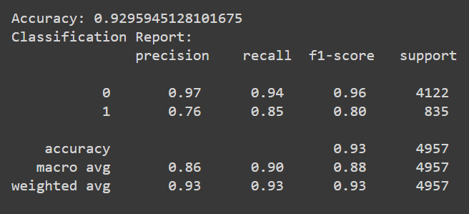

* + Classification Report of **CNN Model**:

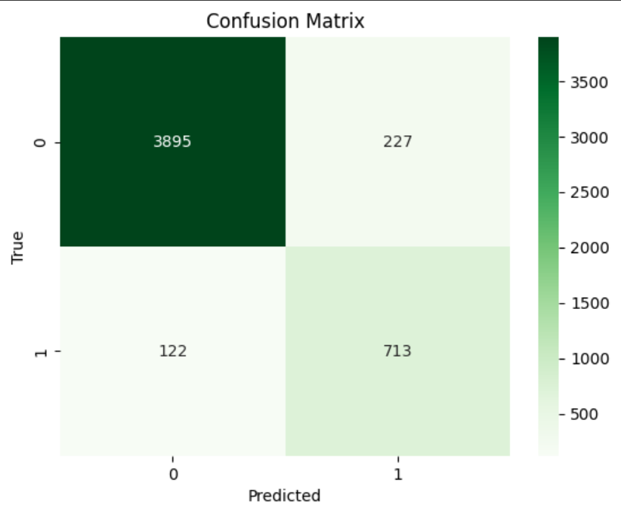

1. **Evaluation metrics**

* **Key Matrix for Evaluation: F1 Score**

The F1 score is the harmonic mean of precision and recall, providing a single metric to assess the balance between the two.

* + Why F1 Score Over Other Parameters:
* Balance of Precision and Recall: The F1 score strikes a balance between precision and recall, making it suitable for tasks where both false positives and false negatives have significant consequences. In hate speech detection, misidentifying non-hate speech tweets as hate speech (false positives) or failing to identify hate speech tweets (false negatives) can impact the effectiveness of content moderation.
* Suitability for Imbalanced Datasets: In Tweeter datasets, hate speech instances may be rare compared to non-hate speech content. The F1 score's harmonic mean ensures that both types of errors are equally penalized, providing a fair assessment of model performance across classes.

F1 Scores Achieved Using **Convolutional Neural Networks (CNN):**

**Class 0:** 0.96

**Class 1:** 0.80